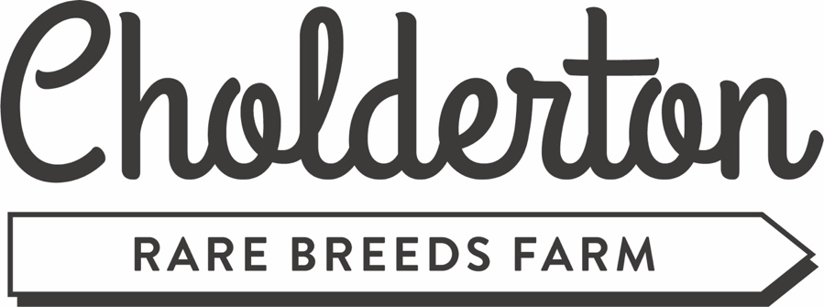
Christmas Craft Fair – Application Form
Date: Saturday 26th & Sunday 27th November 2022
Time:
- Stallholders set up from 8am both days
- Last admission for stallholders 9am
- Doors open to the public between 10am – 4pm
Location:
Vine View events barn – 30-40 stalls
Outside – unlimited stalls
Please Note:
- You must bring your own gazebo (if outside), table & chair(s)
- Hire of table £5 per table per day & chair £3 per chair per day
- Size of tables limited to 6x4 feet
- Gazebo size limited to 10x10 feet
- Stallholders cannot start to pack up before 4pm
- Maximum 2 stallholders per stall
Cost:
- Indoor stall £30 for two days
- Outdoor stall £25 for two days
- Food trucks £60 for two days
- Payments are non-refundable
- Lunch & drinks can also be pre-ordered
- A donation of a stall item to go towards our raffle (drawn at 3pm)

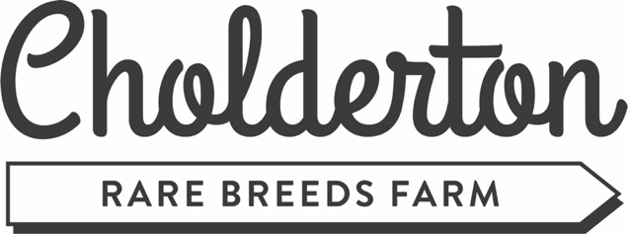
Your Information:
Contact Name:
Business Name:
Contact Telephone Number:
Email Address:
Home Address:
Website URL:
Instagram:
Facebook:
Twitter:
Are you wanting to be inside or outside (delete one): INSIDE / OUTSIDE
Table required: Y / N
Number of tables required:
Chair required: Y / N
Number of chairs required:
What items will you be selling (please attach photos of your goods):
Find us online & share:
https://choldertonrarebreedsfarm.com/event/annual-christmas-craft-fair-2022/
Facebook Event (please like & share): https://fb.me/e/1b23dQJ3t
All stallholders are responsible for their own insurance and their own goods and personal items. By completing & returning this form, you are confirming that you acknowledge these terms.

